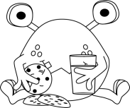

**Name:** Mrs. Sanford

AGE:  
40_+

**All about Me!**

Fun Facts about Me:

* Daughter: Amanda is studying to become a music teacher.
* Son: Christopher is in the army

Things I Like:

School My children

My deck & pool chocolate

My students reading

Some of My Friends:

Mrs. Aucoin Mrs. James

Mrs. Newhook-MacDonald

Mrs. Pashkoski

Things I Can Do:

Solve story problems

Teach swim

Read cross-stitch

Write stories bake